Messy Church does Morning Worship
16 August 2020

Light a candle as a symbol of Christ’s presence with you, and to remind us that we are praying as a church family.

WELCOME
O Lord open our lips.
And our mouths shall proclaim your praise.

SONG: Guide me O thou great Redeemer – sung by Bobby Coates, accompanied by Harry Coates

Guide me o thou great redeemer,
Pilgrim through this barren land.
I am weak but thou art mighty,
Hold me with thy powerful hand.
Bread of heaven, bread of heaven,
Feed me now and evermore,
Feed me now and evermore.

Open now the crystal fountain,
Whence the healing stream doth flow.
Let the fiery cloudy pillar
Lead me all my journey through.
Strong deliverer, strong deliverer,
Be thou still my strength and shield,
Be thou still my strength and shield.

When I tread the verge of Jordan,
Bid my anxious fears sub-side.
Death of death and hell’s destruction,
Land me safe on Canaan’s side.
Songs and praises, songs and praises,
I will ever give to thee,
I will ever give to thee.

BIBLE STORY
John 4: 1-14; 25-26 - read by Clare Coates
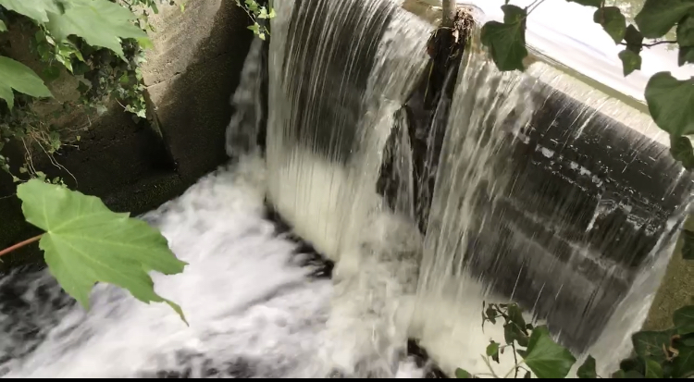
Now Jesus learned that the Pharisees had heard that he was gaining and baptizing more disciples than John— ² although in fact it was not Jesus who baptized, but his disciples. ³ So he left Judea and went back once more to Galilee.
⁴ Now he had to go through Samaria. ⁵ So he came to a town in Samaria called Sychar, near the plot of ground Jacob had given to his son Joseph. ⁶ Jacob’s well was there, and Jesus, tired as he was from the journey, sat down by the well. It was about noon.
⁷ When a Samaritan woman came to draw water, Jesus said to her, “Will you give me a drink?” ⁸ (His disciples had gone into the town to buy food.)
⁹ The Samaritan woman said to him, “You are a Jew and I am a Samaritan woman. How can you ask me for a drink?” (For Jews do not associate with Samaritans.^{[a]})
¹⁰ Jesus answered her, “If you knew the gift of God and who it is that asks you for a drink, you would have asked him and he would have given you living water.”
¹¹ “Sir,” the woman said, “you have nothing to draw with and the well is deep. Where can you get this living water? ¹² Are you greater than our father Jacob, who gave us the well and drank from it himself, as did also his sons and his livestock?”
¹³ Jesus answered, “Everyone who drinks this water will be thirsty again, ¹⁴ but whoever drinks the water I give them will never thirst. Indeed, the water I give them will become in them a spring of water welling up to eternal life.”
¹⁵ The woman said to him, “Sir, give me this water so that I won’t get thirsty and have to keep coming here to draw water.” ………²⁵ The woman said, “I know that the Messiah is coming. When he comes, he will explain everything to us.”
²⁶ Then Jesus declared, “I, the one speaking to you—I am he.”
TALK – Zoe Clayton
ACTIVITIES – for further details see our activities sheet
1. Holy Spirit Hovercraft
2. Parting of the Red Sea

3. Apple Boats

PRAYERS – Simon Taylor

COLLECT
Lord of heaven and earth,
as Jesus taught his disciples to be persistent in prayer,
give us patience and courage never to lose hope,
but always to bring our prayers before you;
through Jesus Christ our Lord. Amen.

LORD’S PRAYER

CONCLUSION
Welsh Blessing
God the sender, send us.
God the sent, come with us.
God the strengthener of those who go,
empower us, that we may go
forever and wherever, with you,
Father, Son and Holy Spirit. Amen.
(from the Church in Wales)
Prelude, Op.28, No. 15 “Raindrop”, Frederic Chopin, played by John Bryden

