Messy Church Activities Sheet Sunday 24 May 2020
Crafts
Chariot Races using Cup and box Chariots

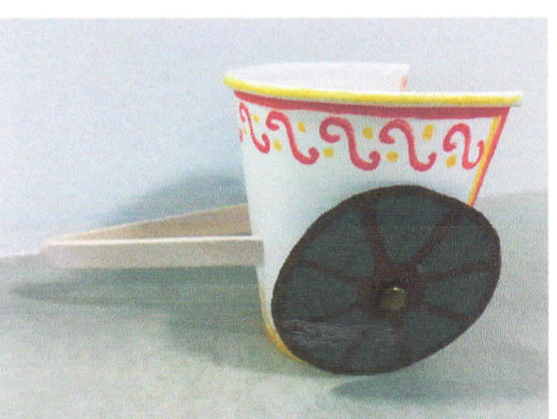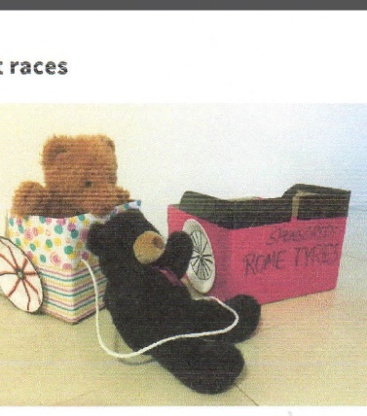
You will need: an assortment of boxes and paper cups; glue; scissors; card to make the wheels; string or rope; coloured paper; lolly sticks or sticks; teddies to sit in the boxes!
1. Use the boxes and paper cups to design a chariot (or two!).
2. Cut out the back of the box or cup.
3. Cut out 2 wheel shapes and attach to the chariot.
4. Using the sticks, create a shaft.
5. Decorate the chariot with coloured pens etc.
6. Have a chariot race with members of your family!
Talk about: What it would have been like in Bible times to ride in a chariot? How else did people travel in those times?

Scroll

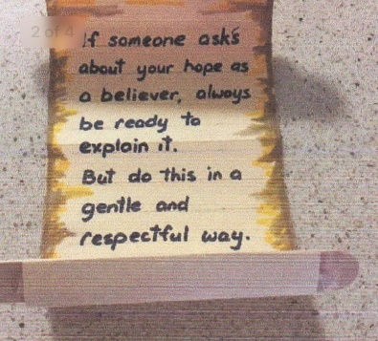
You will need: lolly sticks, scissors, glue, white paper, tea bags, pens.
1. Make a cup of strong tea! Drain the tea bags and put them in a bowl. Leave them to cool.
2. Cut out a long rectangle and glue one lolly stick at the top and another at the bottom.
3. Take your tea bag and spread it all over the paper to make it look old and discoloured. Leave it to dry.
4. Once dry, write: “If someone asks about your hope as a believer, always be ready to explain it. But do this in a gentle and respectful way.”
Talk about: What is your name and what do? How did you become a Christian? What is your favourite Bible story and why? Who do you look up to and why?

Deacon Philip’s footprint
“How Beautiful are the feet of them that preach good news.” Romans 10:15
You will need: White card; pens; scissors; glue; assortment of coloured paper; glitter!

1. Take a piece of white card.
2. Draw around your foot.
3. Carefully cut it out.
4. Stick it onto another piece of card.
5. Spread glue all over and then stick on your coloured pieces of paper. You could use scraps from magazines, or pieces of tissue paper, or even scraps of cloth. Add glitter if you want to!!
6. Write: “How beautiful are the feet of them that preach the good news.” Romans 10:15.
Think about: How people read the Bible in the past. How did we learn about Jesus? How did the Bible come to us? How can we tell people about Jesus?

Prayers: Coffee bean prayers
You will need: a glass jar; a twig with a few branches; a handful of coffee beans and stones; card cut into the shape of a coffee bean; pens; string or ribbon.
1. Fill your glass jar with a layer of stones. Add a branch. Add more stones then a top layer of coffee beans, if you have them.
2. Cut your card into coffee bean shapes.
3. Write your prayers on the beans and tie them to your prayer tree.
4. Pray for – our country; those who are ill; those who are alone; our families; our friends; ourselves. 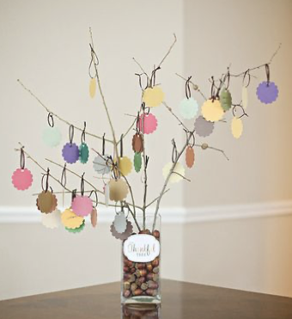 Prayer tree

