Messy Forest Church
Sunday 16 May 2021 Activities Sheet
1. I give you my hands to do your work 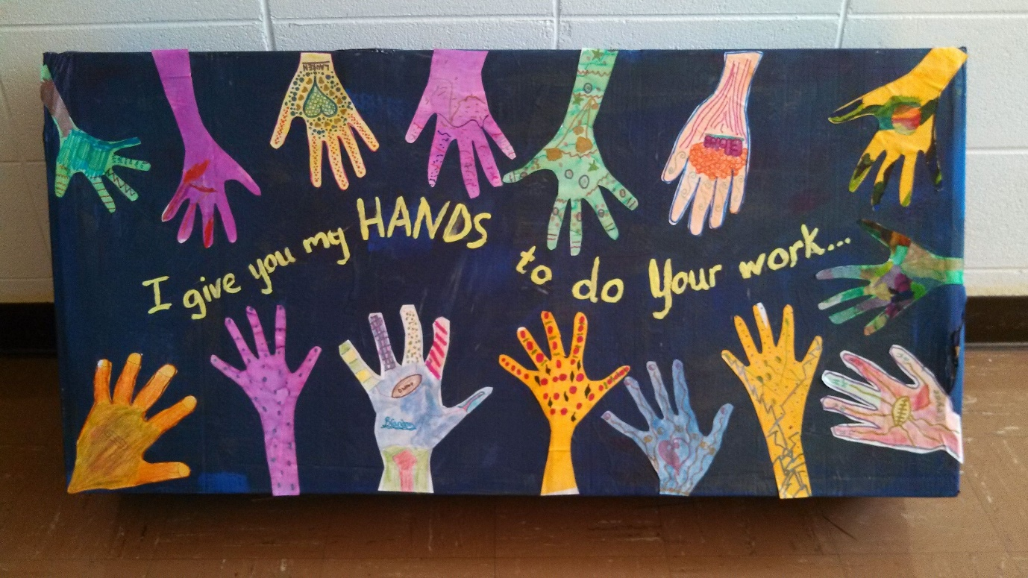
You will need: a poster; paper; scissors; glue
Method:
- Draw around your hand
- Cut it out
- Colour in and decorate
- Add to the poster by gluing it on!
2. Charity Paper Bags
You will need: Paper carrier bags or boxes; paper; glue; pens; stickers
Method:
- Decorate your bag or box
- Take it home and fill it up with unwanted items such as clothes, toys etc
- Donate to your local charity shop – why not drop it off at the Children’s Society in Sawston?
3. Camel
You will need: old egg boxes; card; scissors; glue; pipe cleaners
Method:
- Cut your piece of card into the shape of a camel’s head and neck, using a template.
- Cut a long strip for its tail. Add fringing at the end.

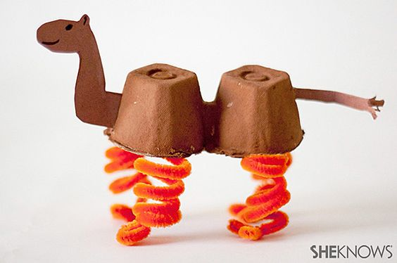

- Take a strip of two egg shapes from a carton. Turn upside down.
- Add four coiled pipe cleaners for its legs by sticking to the underside of the egg shape.
- Stick on the camel’s head and tail.
Prayers
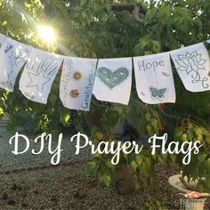
You will need: paper cut into squares; a long line of string to be hung up; pens, collage materials; glue; pegs
Method:
- Write or draw your prayers onto a piece of paper; decorate however you wish
- Add to the prayer line
- LEADER: pray using the prayers and end with the Lord’s Prayer

