Activities Forest Messy Church September 20 2020
Craft
Bunting
You will need:
- Large triangles of paper in autumnal colours
Method:
- Paint leaf shapes onto the sheet. Or paint leaves/vegetables and press them onto the paper to make an impression
- Leave to dry
- Once dry, they will, be strung together to make harvest bunting!

Dragon leaf collage
You will need: to gather leaves, seeds, sticks, conkers etc; paper; glue
Method:
- Spend 5 minutes gathering what you can see
- Create a dragon collage as a reminder that St Michael led the angels in the defence of heaven and won, defeating the dragon.
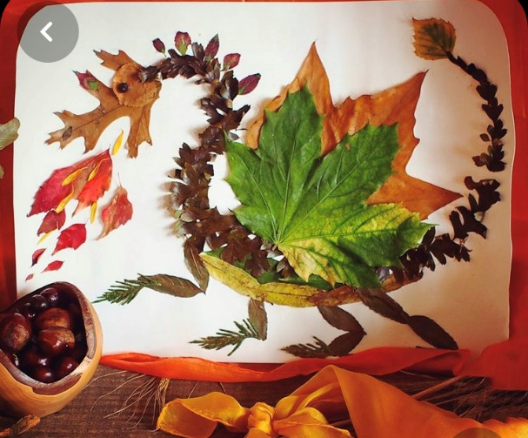
Charcoal drawing: ADULT SUPERVISION REQUIRED
You will need:
- A fire pit
- Sticks wrapped in foil
Method:
- Wrap each stick with foil, ensuring they are completely covered
- Place the sticks into the fire pit as a bundle
- Leave for 20 minutes – they will have stopped flaming and smoking by this stage
- Carefully remove from the fire with tongs and allow them completely to cool
- Have fun drawing on stones, logs and bark or alternatively card in your craft pack

Bug Hotel
You will need:
- Cardboard tubes; logs; leaves; moss; stones; sticks; grass; egg boxes.
Method:
- Find a space if you are leaving it here. If you are taking it home, build it carefully on a container to carry home & place in your garden. At home you could build something bigger and use wood and soil.
- First make a basic structure using materials provided and those found on our sound safari.
- Make lots of gaps for bugs to crawl inside!
- Add leaves, moss, stones; sticks.
- Create lots of levels!
The idea is to provide all sorts of nooks and crannies, crevices, tunnels and cosy beds

