Activities Sheet
Sunday 6 December 2020
1. Angels
You will need: a wooden angel shaped peg; angel wings; glue; pens
Method:
- Using the materials provided, make an angel. Use pens to give eyes, nose and smile.
2. Christmas Wreath
You will need: a pre prepared large cardboard ring with a cut to one side; rubber bands; pine tree branches and other foliage; scissors; glue; ribbon
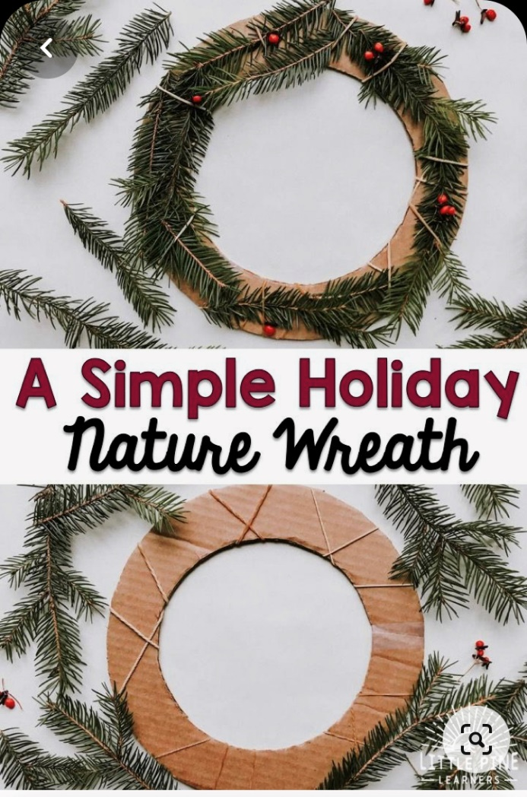
Method:
- You will need a pre prepared cardboard ring. Draw a large circle then a smaller one on the inside. Cut out the ring, then cut a line through the loop to get to the inside. This cut will also help us put the rubber bands on the loop.
- Put the rubber bands on the loop and tape it up to create the wreath base
- Weave the pine branches through the rubber bands.
- Add the other foliage but be careful not to use poisonous berries – e.g. Yew
- Add ribbon to hang up

3. Twig stars

You will need: 5 straight sticks of equal length; string.

Method:

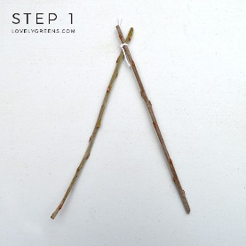 Step 1: Matching the ends
Begin by taking two twigs and locating which ends are thicker and thinner if relevant. Bind the two twigs together with string so that one thick end is connected to one thin end. Doing this for each attachment point will give the star more stability.
Step 2: Add the third twig
Add the next twig on, making sure that it’s the top-crossing twig at the attachment point. Each new twig you attach should be placed on top of the last one.
Adjust the position of the third twig so that the angle inside matches the angle at the top of your star. The third twig should also lie on top of the first twig as pictured.
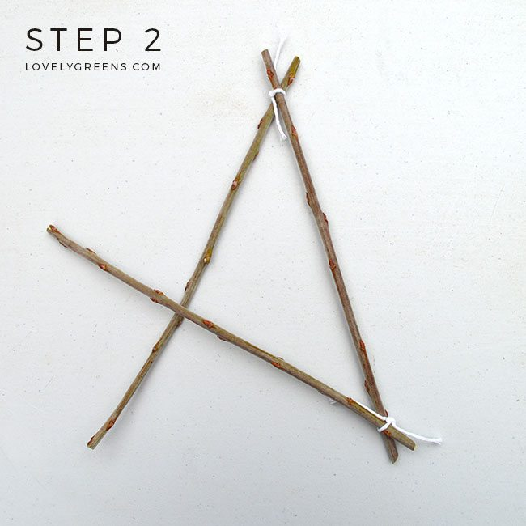

Step 3: Weaving Under & Over
Weave the fourth twig through the twigs forming the star’s top point. Weave under and over and attach it with string afterwards. It might be easier to look at the photo below.
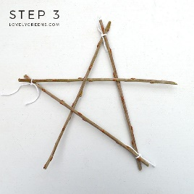

Step 4: Adding the last twig
When adding the last twig, it’s also easier to do the weaving first and then tie it in. Keep in mind:
- Thick end to thin
- Upper or lower placement is dependent on how the last twig was attached
- Weave under, then over 