Forest Church Sunday 2 May 2021: Activities Sheet
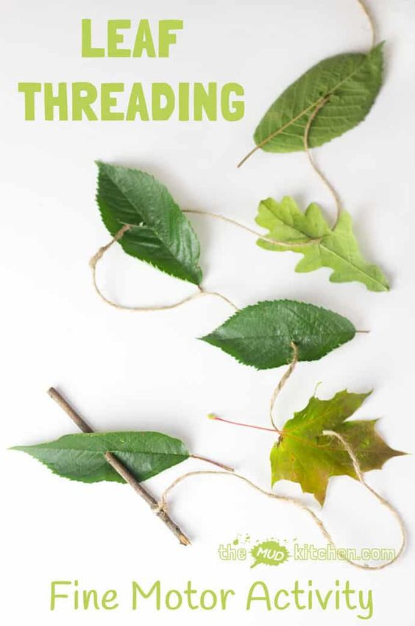
1. Leaf Threading
You will need: a stick; long piece of string; leaves!
Method:
- Forage for lots of different shaped leaves and a stick
- Use the stick to make holes in the leaves
- String together
- Use to hang up as decorations at home or in the churchyard
2. ‘I am the Vine’ Button Tree
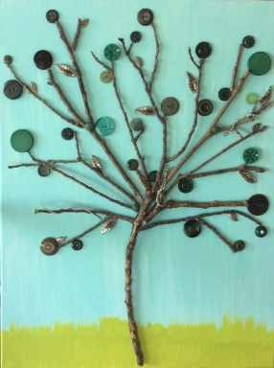 You will need: a piece of paper; buttons; stickers; glue; pens
Method:
- Using a pen, draw the shape of a tree with lots of branches on a piece of paper
- Decorate with buttons, stickers etc
Prayer Activity: sticky note grape prayers
You will need: a Cross; Sticky notes – green and purple. Pens
Method:
- Write your prayers on a sticky note & add to the cross during the craft time. Set up a side table to the standing cross for this activity.
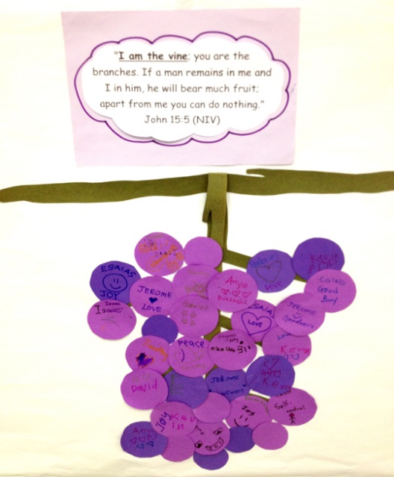
- Conclude with the Lord’s Prayer.

