Sixth Sunday of Easter
17 May 2020

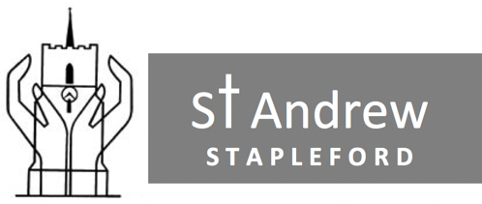

WELCOME
The Lord be with you
and also with you.

Alleluia. Christ is risen.
He is risen indeed. Alleluia.

Light a candle as a symbol of Christ’s presence with you, and to remind us that we are praying as a church family.

THE WORK OF THE LINK – Liz Megson

SIX QUESTIONS – Trish Maude

READING – Acts 17.22-31 read by Steve Jones
²² Paul then stood up in the meeting of the Areopagus and said: ‘People of Athens! I see that in every way you are very religious. ²³ For as I walked around and looked carefully at your objects of worship, I even found an altar with this inscription: to an unknown god. So you are ignorant of the very thing you worship – and this is what I am going to proclaim to you.
²⁴ ‘The God who made the world and everything in it is the Lord of heaven and earth and does not live in temples built by human hands. ²⁵ And he is not served by human hands, as if he needed anything. Rather, he himself gives everyone life and breath and everything else. ²⁶ From one man he made all the nations, that they should inhabit the whole earth; and he marked out their appointed times in history and the boundaries of their lands. ²⁷ God did this so that they would seek him and perhaps reach out for him and find him, though he is not far from any one of us. ²⁸ “For in him we live and move and have our being.”[ As some of your own poets have said, “We are his offspring.”
²⁹ ‘Therefore since we are God’s offspring, we should not think that the divine being is like gold or silver or stone – an image made by human design and skill. ³⁰ In the past God overlooked such ignorance, but now he commands all people everywhere to repent. ³¹ For he has set a day when he will judge the world with justice by the man he has appointed. He has given proof of this to everyone by raising him from the dead.’

SERMON – Simon Taylor

PRAYERS – led by Mary Cooper
During the prayers, this response will be used
In your mercy, hear our prayer.

COLLECT
Risen Christ,
by the lakeside you renewed your call to your disciples:
help your Church to obey your command
and draw the nations to the fire of your love,
to the glory of God the Father.
Amen.

LORD’S PRAYER
HYMN – sung by the Needle family
We are marching in the light of God,
we are marching in the light of God.
We are marching in the light of God,
we are marching in the light of God.
We are marching,
Oo-ooh! we are marching in the light of God.
We are marching,
Oo-ooh! we are marching in the light of God.

First verse again In Swahili:
Siyahamb' ekukhanyen' kwenkhos' (x4)
Siyahamba,
Oo-ooh! Siyahamb' ekukhanyen' kwenkhos' (x2)

We are living in the love of God …,

We are moving in the power of God …

THE GRACE IN SWAHILI
Neema ya bwana wetu Yesu Kristo
na pendo wa Mungu
na ushirika wa Roho Mtakatifu
ukae nasi sote sasa
na hata milele.
Amin.

May the grace of our Lord Jesus Christ
and the love of God
and the fellowship of the Holy Spirit,
be with us all now
and for evermore.
Amen.

CONCLUSION – a message from Bishop James of Masasi

