
Christian Living
Serving God:
Giving Ourselves

Introduction page 2
Week 1 / 6 September Use Your Gifts page 4
9 am BCP Communion
10.30 am CW Communion
1 Peter 4.7b-11
John 15.1-8
Week 2 / 13 September Be Transformed page 6
9 am BCP Communion
10.30 am Sunday Worship
Romans 12.1-2
John 15.9-17
Week 3 / 27 September One Body page 8
9 am BCP Communion
10.30 am All Age & Family Service
Romans 12.3-5
John 15.18-27
Week 4 / 11 October How Can I Help? page 10
9 am BCP Communion
10.30 am Sunday Worship
Romans 12.6-8
John 16.1-15
Week 5 / 25 October Serve the Lord page 12
9 am BCP Communion
10.30 am CW Communion
Romans 12.9-21
John 16.16-33
Introduction
This series is about living as a Christian. We look at that issue using a little of the writings of the apostle Peter to start with, and rather more of Paul, following his thinking through chapter 12 of his letter to the Romans.
As well as asking how we should live as Christians in the world, we ask how we should each serve as part of the church community, focussing on that issue particularly in the first and fourth weeks.
It is time for this series because, putting it bluntly, we are short of volunteers. It seemed right to take us back to scripture, to see if that will scratch some more itches to serve, as it were.
It is sometimes said that people are reluctant to serve in church. Much like being near to a helicopter, they fear being sucked into the rotas. I’m not sure that this is true. Not the helicopter rotas; that fear makes sense for self-preservation! I’m not sure that people are reluctant to serve in church. There are plenty of other pressures making involvement difficult, but not reluctance.
But why do we do it, or why should we do it, and what do we benefit from giving our time and talents? How does the church community benefit? How does the mission of the church benefit?
This series begins to ponder the benefits of giving our time and talents in enabling our church to thrive.
In Romans, Paul places service with our time and talents within acts of worship. Our service with our time and talents gives our worth to God. This is how we can worship God. That is not to say that it is all one-way, only us giving. We do well to remember that, “worship is not that which I do, but that which is done in me. That is, worship, which reveals Christ, forms me by making me aware that Jesus is my spirituality and that worship is to form my spiritual life into the patterns of living into the death and resurrection of Jesus.”
When we give our time and talents, we engage in acts of worship that change us and show Jesus to others. Our service to one another ought to see us changed by Jesus’ pattern of death and resurrection, daily dying to self. As we engage in loving service, we are graciously changed and conformed to Christ’s image rather than any other image we might adopt.

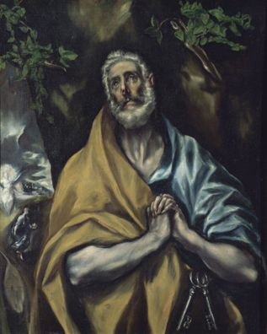
WEEK 1 / 6 September Use Your Gifts
The Repentant St Peter, El Greco (1541-1614) after 1605
Oil on canvas, The Phillips Collection, New York

1 PETER 4.7b-11
^{7b} Be alert and of sober mind so that you may pray. ⁸ Above all, love each other deeply, because love covers over a multitude of sins. ⁹ Offer hospitality to one another without grumbling. ¹⁰ Each of you should use whatever gift you have received to serve others, as faithful stewards of
God’s grace in its various forms. ¹¹ If anyone speaks, they should do so as one who speaks the very words of God. If anyone serves, they should do so with the strength God provides, so that in all things God may be praised through Jesus Christ. To him be the glory and the power for ever and ever. Amen.

JOHN 15.1-8
15 ‘I am the true vine, and my Father is the gardener. ² He cuts off every branch in me that bears no fruit, while every branch that does bear fruit he prunes so that it will be even more fruitful. ³ You are already clean because of the word I have spoken to you. ⁴ Remain in me, as I also remain in you. No branch can bear fruit by itself; it must remain in the vine. Neither can you bear fruit unless you remain in me.
⁵ ‘I am the vine; you are the branches. If you remain in me and I in you, you will bear much fruit; apart from me you can do nothing. ⁶ If you do not remain in me, you are like a branch that is thrown away and withers; such branches are picked up, thrown into the fire and burned. ⁷ If you remain in me and my words remain in you, ask whatever you wish, and it will be done for you. ⁸ This is to my Father’s glory, that you bear much fruit, showing yourselves to be my disciples.

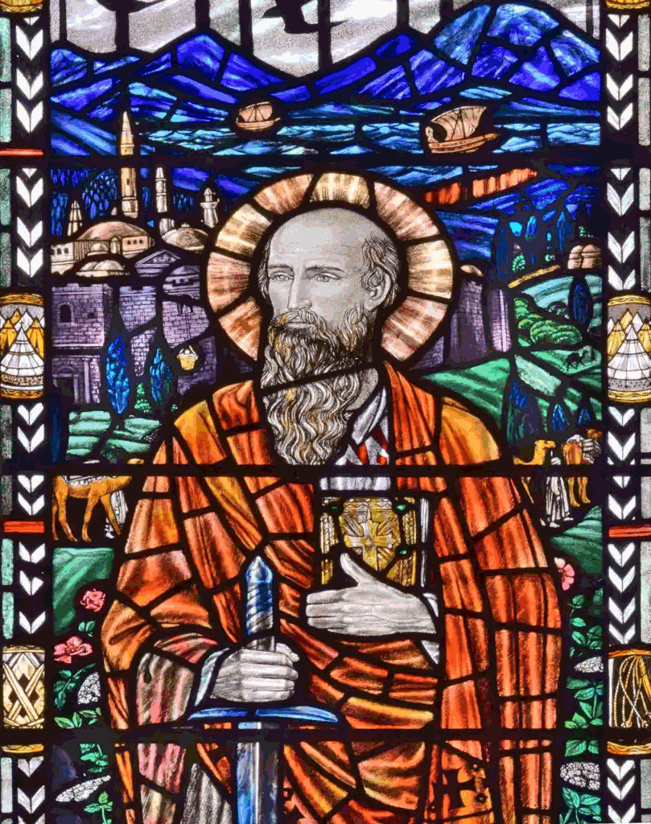
WEEK 2 / 13 September Be Transformed
Portrait of St Paul (detail) Sister Margaret Agnes Rope (1882-1953) 1914
Stained glass. Church of St Peter and St Paul, Newport, Shropshire

ROMANS 12.1-2
12 Therefore, I urge you, brothers and sisters, in view of God’s mercy, to offer your bodies as a living sacrifice, holy and pleasing to God – this is your true and proper worship. ² Do not conform to the pattern of this world, but be transformed by the renewing of your mind.
Then you will be able to test and approve what God’s will is – his good, pleasing and perfect will.

JOHN 15.9-17
⁹ ‘As the Father has loved me, so have I loved you. Now remain in my love. ¹⁰ If you keep my commands, you will remain in my love, just as I have kept my Father’s commands and remain in his love. ¹¹ I have told you this so that my joy may be in you and that your joy may be complete. ¹² My command is this: love each other as I have loved you. ¹³ Greater love has no one than this: to lay down one’s life for one’s friends. ¹⁴ You are my friends if you do what I command. ¹⁵ I no longer call you servants, because a servant does not know his master’s business. Instead, I have called you friends, for everything that I learned from my Father I have made known to you. ¹⁶ You did not choose me, but I chose you and appointed you so that you might go and bear fruit – fruit that will last – and so that whatever you ask in my name the Father will give you. ¹⁷ This is my command: love each other.

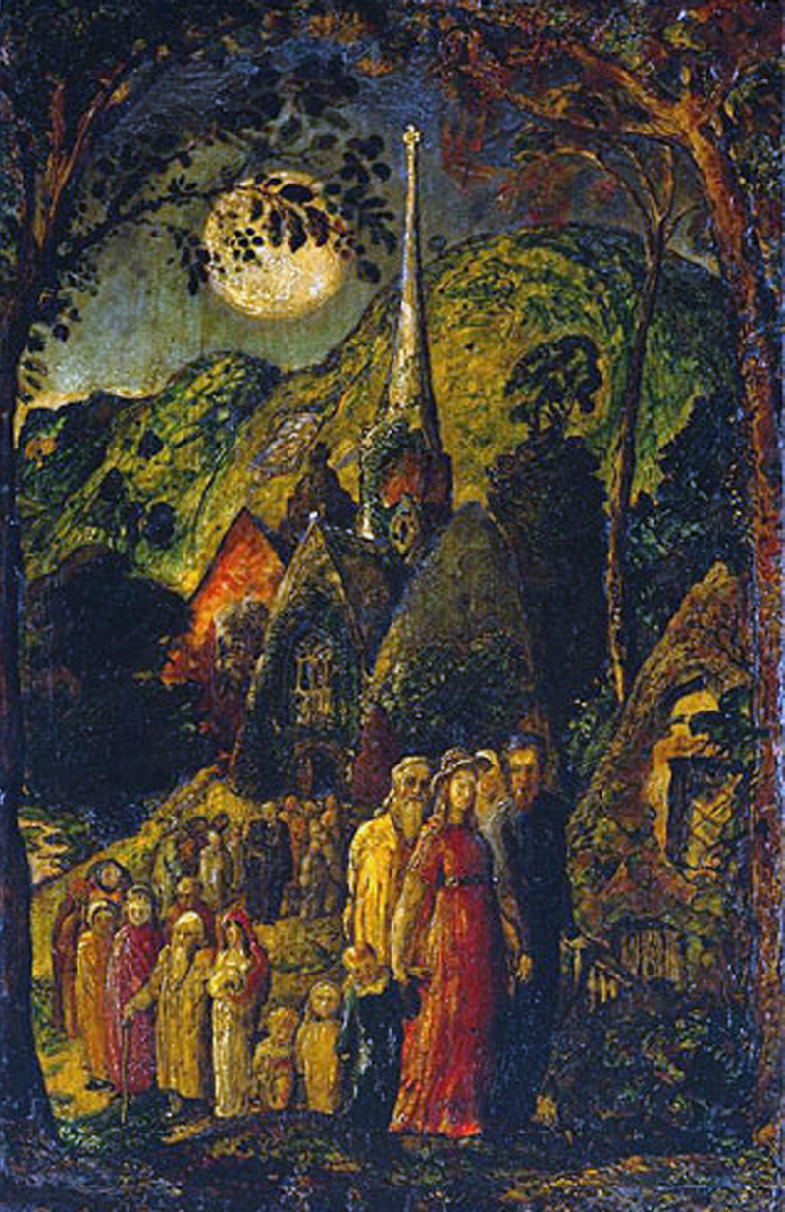
WEEK 3 / 27 September One Body
Coming from Evening Church, Samuel Palmer (1805-1881) 1830
Pen and Indian ink. Tate Gallery, London
ROMANS 12.3-5
³ For by the grace given me I say to every one of you: do not think of yourself more highly than you ought, but rather think of yourself with sober judgment, in accordance with the faith God has distributed to each of you. ⁴ For just as each of us has one body with many members, and these members do not all have the same function, ⁵ so in Christ we, though many, form one body, and each member belongs to all the others.

JOHN 15.18-27
¹⁸ ‘If the world hates you, keep in mind that it hated me first. ¹⁹ If you belonged to the world, it would love you as its own. As it is, you do not belong to the world, but I have chosen you out of the world. That is why the world hates you. ²⁰ Remember what I told you: “A servant is not greater than his master.” If they persecuted me, they will persecute you also. If they obeyed my teaching, they will obey yours also. ²¹ They will treat you this way because of my name, for they do not know the one who sent me. ²² If I had not come and spoken to them, they would not be guilty of sin; but now they have no excuse for their sin. ²³ Whoever hates me hates my Father as well. ²⁴ If I had not done among them the works no one else did, they would not be guilty of sin. As it is, they have seen, and yet they have hated both me and my Father. ²⁵ But this is to fulfil what is written in their Law: “They hated me without reason.”
²⁶ ‘When the Advocate comes, whom I will send to you from the Father – the Spirit of truth who goes out from the Father – he will testify about me. ²⁷ And you also must testify, for you have been with me from the beginning.

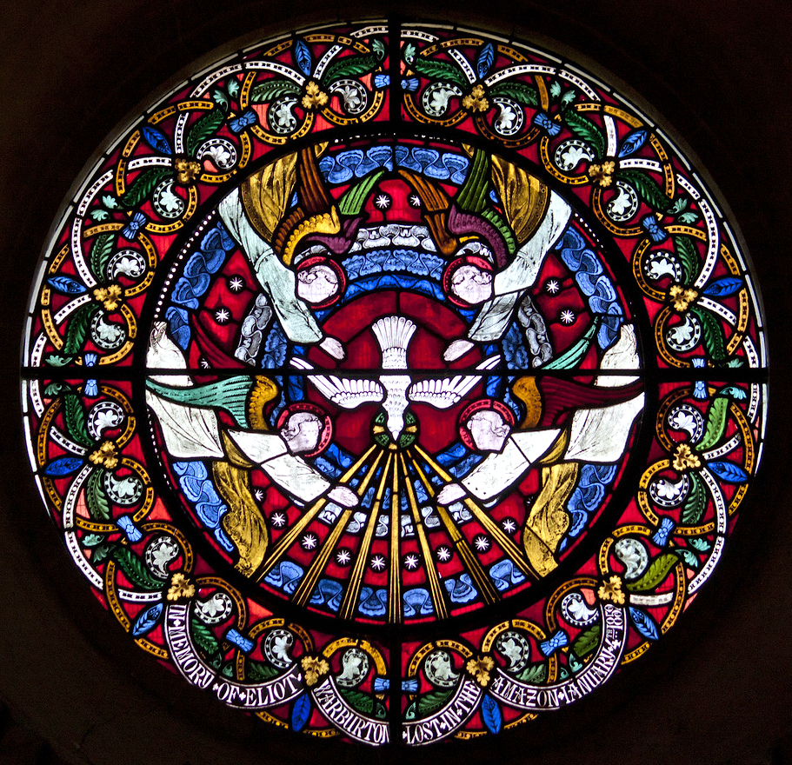
WEEK 4 / 11 September How Can I Help?
Spirit with the Sevenfold Gifts unknown (c. C19)
Stained glass. St. Mary’s Church, Iffley

ROMANS 12.6-8
⁶ We have different gifts, according to the grace given to each of us. If your gift is prophesying, then prophesy in accordance with your faith; ⁷ if it is serving, then serve; if it is teaching, then teach; ⁸ if it is to encourage, then give encouragement; if it is giving, then give generously; if it is to lead, do it diligently; if it is to show mercy, do it cheerfully.
JOHN 16.1-15
16 ‘All this I have told you so that you will not fall away. ² They will put you out of the synagogue; in fact, the time is coming when anyone who kills you will think they are offering a service to God. ³ They will do such things because they have not known the Father or me. ⁴ I have told you this, so that when their time comes you will remember that I warned you about them. I did not tell you this from the beginning because I was with you, ⁵ but now I am going to him who sent me. None of you asks me, “Where are you going?” ⁶ Rather, you are filled with grief because I have said these things. ⁷ But very truly I tell you, it is for your good that I am going away. Unless I go away, the Advocate will not come to you; but if I go, I will send him to you. ⁸ When he comes, he will prove the world to be in the wrong about sin and righteousness and judgment: ⁹ about sin, because people do not believe in me; ¹⁰ about righteousness, because I am going to the Father, where you can see me no longer; ¹¹ and about judgment, because the prince of this world now stands condemned.
¹² ‘I have much more to say to you, more than you can now bear. ¹³ But when he, the Spirit of truth, comes, he will guide you into all the truth. He will not speak on his own; he will speak only what he hears, and he will tell you what is yet to come. ¹⁴ He will glorify me because it is from me that he will receive what he will make known to you. ¹⁵ All that belongs to the Father is mine. That is why I said the Spirit will receive from me what he will make known to you.’

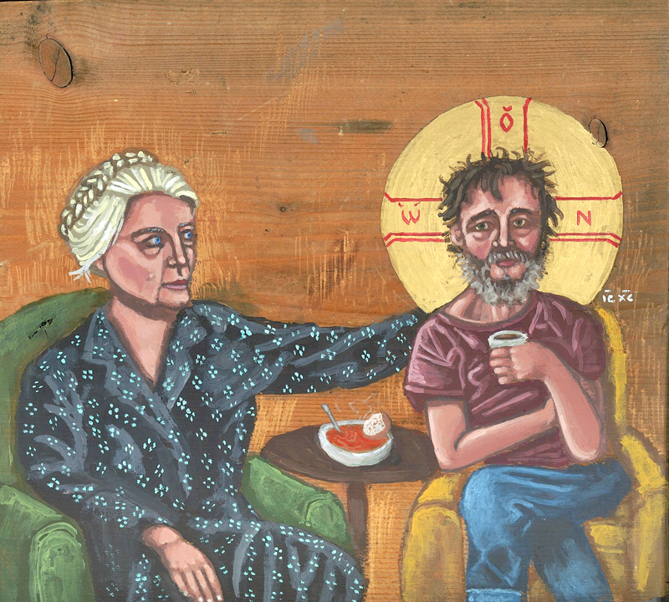
WEEK 5 / 25 October Serve the Lord
Don’t Call Me a Saint: Dorothy Day with Homeless Christ Kelly Latimore (b.1986) 2015
Acrylic and gold leaf on wood. New York

ROMANS 12.9-21
⁹ Love must be sincere. Hate what is evil; cling to what is good. ¹⁰ Be devoted to one another in love. Honour one another above yourselves. ¹¹ Never be lacking in zeal, but keep your spiritual fervour, serving the Lord. ¹² Be joyful in hope, patient in affliction, faithful in prayer. ¹³ Share with the Lord’s people who are in need. Practise hospitality.
¹⁴ Bless those who persecute you; bless and do not curse. ¹⁵ Rejoice with those who rejoice; mourn with those who mourn.
¹⁶ Live in harmony with one another. Do not be proud, but be willing to associate with people of low position. Do not be conceited.
¹⁷ Do not repay anyone evil for evil. Be careful to do what is right in the eyes of everyone. ¹⁸ If it is possible, as far as it depends on you, live at peace with everyone. ¹⁹ Do not take revenge, my dear friends, but leave room for God’s wrath, for it is written: ‘It is mine to avenge; I will repay,’ says the Lord. ²⁰ On the contrary:
‘If your enemy is hungry, feed him;
if he is thirsty, give him something to drink.
In doing this, you will heap burning coals on his head.’
²¹ Do not be overcome by evil, but overcome evil with good.

JOHN 16.16-33
¹⁶ Jesus went on to say, ‘In a little while you will see me no more, and then after a little while you will see me.’
¹⁷ At this, some of his disciples said to one another, ‘What does he mean by saying, “In a little while you will see me no more, and then after a little while you will see me,” and “Because I am going to the Father”?’ ¹⁸ They kept asking, ‘What does he mean by “a little while”? We don’t understand what he is saying.’
¹⁹ Jesus saw that they wanted to ask him about this, so he said to them, ‘Are you asking one another what I meant when I said, “In a little while you will see me no more, and then after a little while you will see me”? ²⁰ Very truly I tell you, you will weep and mourn while the world rejoices. You will grieve, but your grief will turn to joy. ²¹ A woman giving birth to a child has pain because her time has come; but when her baby is born she forgets the anguish because of her joy that a child is born into the world.
²² So with you: now is your time of grief, but I will see you again and you will rejoice, and no one will take away your joy. ²³ In that day you will no longer ask me anything. Very truly I tell you, my Father will give you whatever you ask in my name. ²⁴ Until now you have not asked for anything in my name. Ask and you will receive, and your joy will be complete.
²⁵ ‘Though I have been speaking figuratively, a time is coming when I will no longer use this kind of language but will tell you plainly about my Father. ²⁶ In that day you will ask in my name. I am not saying that I will ask the Father on your behalf. ²⁷ No, the Father himself loves you because you have loved me and have believed that I came from God. ²⁸ I came from the Father and entered the world; now I am leaving the world and going back to the Father.’
²⁹ Then Jesus’ disciples said, ‘Now you are speaking clearly and without figures of speech. ³⁰ Now we can see that you know all things and that you do not even need to have anyone ask you questions. This makes us believe that you came from God.’
³¹ ‘Do you now believe?’ Jesus replied. ³² ‘A time is coming and in fact has come when you will be scattered, each to your own home. You will leave me all alone. Yet I am not alone, for my Father is with me.
³³ ‘I have told you these things, so that in me you may have peace. In this world you will have trouble. But take heart! I have overcome the world.’

Five different ways to give and support St Andrew’s Church:

- use our card reader
- cash
- cheque to Stapleford PCC
- as a one-off through our website
standrewstapleford.org/giving
- by setting up a regular donation
through the Parish Giving Scheme -
see standrewstapleford.org/giving for details

Webber, Robert, Ancient-Future Worship: Proclaiming and Enacting God’s Narrative (Grand Rapids: Baker Books, 2008), p. 93.

