
The Prophet Elijah

1 Kings 16.29-33 page 3
Week 1 / 26 July page 4
9 am BCP Communion
1 Kings 17.1-7
Matthew 13.31-33
Week 2 / 2 August page 6
9 am BCP Communion
1 Kings 17.7-16
Matthew 13.44-52
1 Kings 17.17-18.16 page 9
Week 3 / 9 August page 11
9 am BCP Communion
1 Kings 18.17-40
Matthew 14.22-33
Week 4 / 16 August page 15
9 am BCP Communion
10.30 CW Communion
1 Kings 18.41-46
Matthew 15.1-9
Week 5 / 23 August page 17
9 am BCP Communion
1 Kings 19.1-8
Matthew 16.1-4

Five different ways to give and support St Andrew’s Church:

- use our card reader
- cash
- cheque to Stapleford PCC
- as a one-off through our website
standrewstapleford.org/giving
- by setting up a regular donation
through the Parish Giving Scheme -
see standrewstapleford.org/giving for details

1 KINGS 16.29-33
²⁹ In the thirty-eighth year of Asa king of Judah, Ahab son of Omri became king of Israel, and he reigned in Samaria over Israel for twenty-two years. ³⁰ Ahab son of Omri did more evil in the eyes of the Lord than any of those before him. ³¹ He not only considered it trivial to commit the sins of Jeroboam son of Nebat, but he also married Jezebel daughter of Ethbaal king of the Sidonians, and began to serve Baal and worship him. ³² He set up an altar for Baal in the temple of Baal that he built in Samaria. ³³ Ahab also made an Asherah pole and did more to arouse the anger of the Lord, the God of Israel, than did all the kings of Israel before him.
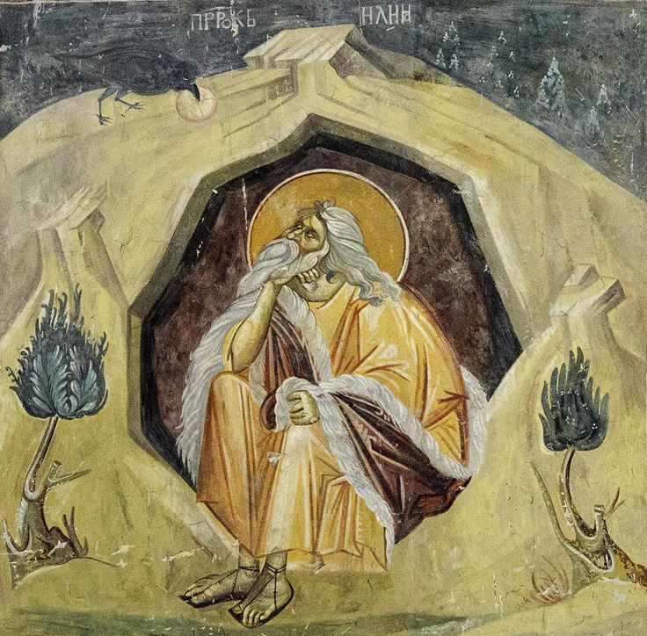
WEEK 1 / 26 July
St Elijah Michael Astrapas & Eutychios (13th-14th century) 1321-22
Fresco. Gračanica Monastery, Kosovo

1 KINGS 17.1-7
17 Now Elijah the Tishbite, from Tishbe in Gilead, said to Ahab, ‘As the Lord, the God of Israel, lives, whom I serve, there will be neither dew nor rain in the next few years except at my word.’
² Then the word of the Lord came to Elijah: ³ ‘Leave here, turn eastward and hide in the Kerith Ravine, east of the Jordan. ⁴ You will drink from
the brook, and I have instructed the ravens to supply you with food there.’
⁵ So he did what the Lord had told him. He went to the Kerith Ravine, east of the Jordan, and stayed there. ⁶ The ravens brought him bread and meat in the morning and bread and meat in the evening, and he drank from the brook.
⁷ Some time later the brook dried up because there had been no rain in the land.

MATTHEW 13.31-33
³¹ Jesus told them another parable: ‘The kingdom of heaven is like a mustard seed, which a man took and planted in his field. ³² Though it is the smallest of all seeds, yet when it grows, it is the largest of garden plants and becomes a tree, so that the birds come and perch in its branches.’
³³ He told them still another parable: ‘The kingdom of heaven is like yeast that a woman took and mixed into about thirty kilograms of flour until it worked all through the dough.’

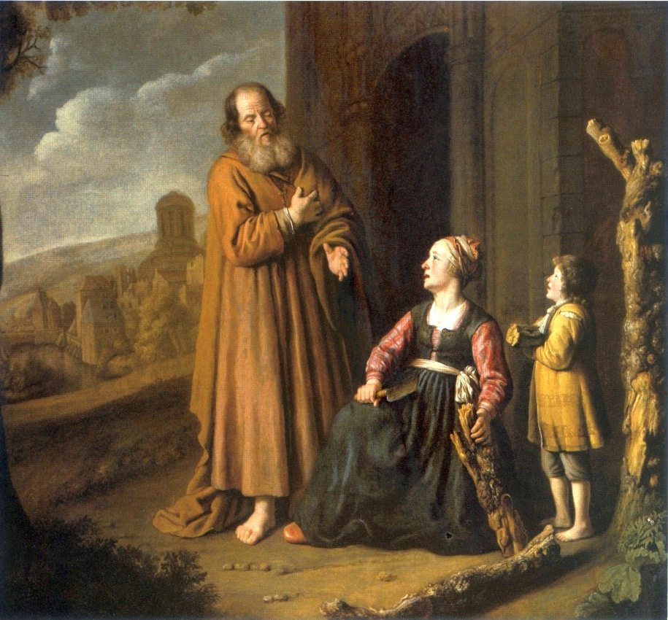
WEEK 2 / 2 August
Elijah and the Widow of Zarephath Jan Victors (1619-76) 1640-50
Oil on canvas. Museum of John Paul II, Warsaw

1 KINGS 17.7-16
⁷ Some time later the brook dried up because there had been no rain in the land. ⁸ Then the word of the Lord came to Elijah: ⁹ ‘Go at once to Zarephath in the region of Sidon and stay there. I have instructed a widow there to supply you with food.’ ¹⁰ So he went to Zarephath. When he came to the town gate, a widow was there gathering sticks.
He called to her and asked, ‘Would you bring me a little water in a jar so I may have a drink?’ ¹¹ As she was going to get it, he called, ‘And bring me, please, a piece of bread.’
¹² ‘As surely as the Lord your God lives,’ she replied, ‘I don’t have any bread – only a handful of flour in a jar and a little olive oil in a jug. I am gathering a few sticks to take home and make a meal for myself and my son, that we may eat it – and die.’
¹³ Elijah said to her, ‘Don’t be afraid. Go home and do as you have said. But first make a small loaf of bread for me from what you have and bring it to me, and then make something for yourself and your son. ¹⁴ For this is what the Lord, the God of Israel, says: “The jar of flour will not be used up and the jug of oil will not run dry until the day the Lord sends rain on the land.”’
¹⁵ She went away and did as Elijah had told her. So there was food every day for Elijah and for the woman and her family. ¹⁶ For the jar of flour was not used up and the jug of oil did not run dry, in keeping with the word of the Lord spoken by Elijah.

MATTHEW 13.44-52
⁴⁴ ‘The kingdom of heaven is like treasure hidden in a field. When a man found it, he hid it again, and then in his joy went and sold all he had and bought that field.
⁴⁵ ‘Again, the kingdom of heaven is like a merchant looking for fine pearls. ⁴⁶ When he found one of great value, he went away and sold everything he had and bought it.
⁴⁷ ‘Once again, the kingdom of heaven is like a net that was let down into the lake and caught all kinds of fish. ⁴⁸ When it was full, the fishermen pulled it up on the shore. Then they sat down and collected the good fish in baskets, but threw the bad away.⁴⁹ This is how it will be at the end of the age. The angels will come and separate the wicked from the righteous ⁵⁰ and throw them into the blazing furnace, where there will be weeping and gnashing of teeth.
⁵¹ ‘Have you understood all these things?’ Jesus asked.
‘Yes,’ they replied.
⁵² He said to them, ‘Therefore every teacher of the law who has become a disciple in the kingdom of heaven is like the owner of a house who brings out of his storeroom new treasures as well as old.’

1 KINGS 17.17-18.16
¹⁷ Some time later the son of the woman who owned the house became ill. He grew worse and worse, and finally stopped breathing. ¹⁸ She said to Elijah, ‘What do you have against me, man of God? Did you come to remind me of my sin and kill my son?’
¹⁹ ‘Give me your son,’ Elijah replied. He took him from her arms, carried him to the upper room where he was staying, and laid him on his bed. ²⁰ Then he cried out to the Lord, ‘Lord my God, have you brought tragedy even on this widow I am staying with, by causing her son to die?’ ²¹ Then he stretched himself out on the boy three times and cried out to the Lord, ‘Lord my God, let this boy’s life return to him!’
²² The Lord heard Elijah’s cry, and the boy’s life returned to him, and he lived. ²³ Elijah picked up the child and carried him down from the room into the house. He gave him to his mother and said, ‘Look, your son is alive!’
²⁴ Then the woman said to Elijah, ‘Now I know that you are a man of God and that the word of the Lord from your mouth is the truth.’
18 After a long time, in the third year, the word of the Lord came to Elijah: ‘Go and present yourself to Ahab, and I will send rain on the land.’ ² So Elijah went to present himself to Ahab.
Now the famine was severe in Samaria, ³ and Ahab had summoned Obadiah, his palace administrator. (Obadiah was a devout believer in the Lord. ⁴ While Jezebel was killing off the Lord’s prophets, Obadiah had taken a hundred prophets and hidden them in two caves, fifty in each, and had supplied them with food and water.)
⁵ Ahab had said to Obadiah, ‘Go through the land to all the springs and valleys. Maybe we can find some grass to keep the horses and mules alive so we will not have to kill any of our animals.’ ⁶ So they divided the land they were to cover, Ahab going in one direction and Obadiah in another.
⁷ As Obadiah was walking along, Elijah met him. Obadiah recognised him, bowed down to the ground, and said, ‘Is it really you, my lord Elijah?’
⁸ ‘Yes,’ he replied. ‘Go tell your master, “Elijah is here.”’
⁹ ‘What have I done wrong,’ asked Obadiah, ‘that you are handing your servant over to Ahab to be put to death? ¹⁰ As surely as the Lord your God lives, there is not a nation or kingdom where my master has not sent someone to look for you. And whenever a nation or kingdom claimed you were not there, he made them swear they could not find you. ¹¹ But now you tell me to go to my master and say, “Elijah is here.” ¹² I don’t know where the Spirit of the Lord may carry you when I leave you. If I go and tell Ahab and he doesn’t find you, he will kill me. Yet I your servant have worshipped the Lord since my youth. ¹³ Haven’t you heard, my lord, what I did while Jezebel was killing the prophets of the Lord? I hid a hundred of the Lord’s prophets in two caves, fifty in each, and supplied them with food and water. ¹⁴ And now you tell me to go to my master and say, “Elijah is here.” He will kill me!’
¹⁵ Elijah said, ‘As the Lord Almighty lives, whom I serve, I will surely present myself to Ahab today.’
¹⁶ So Obadiah went to meet Ahab and told him, and Ahab went to meet Elijah.
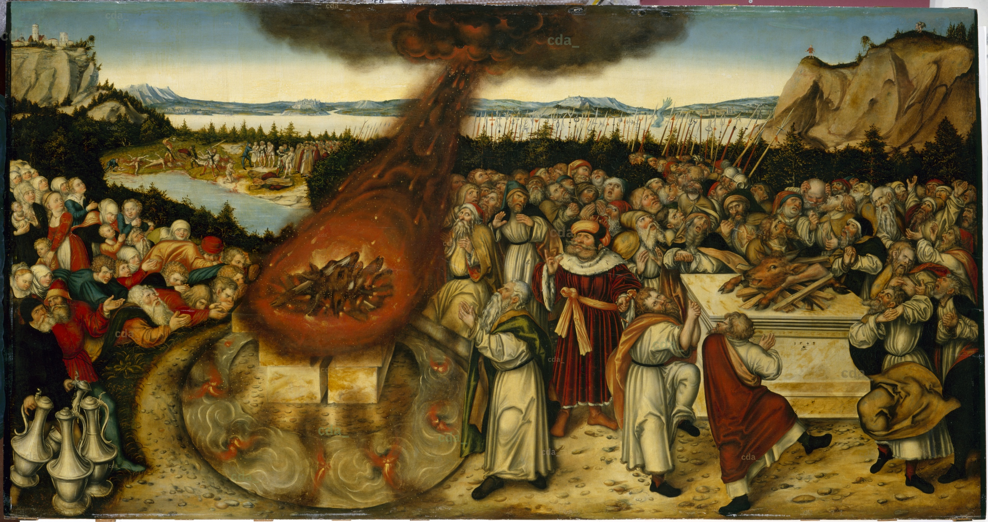
WEEK 3 / 9 August
Elijah and Baal’s Priests Lucas Cranach the Younger (1515-1586) 1545
Oil on canvas. Staatliche Kunstammlungen, Dresden

1 KINGS 18.17-40
¹⁷ When Ahab saw Elijah, he said to him, ‘Is that you, you troubler of Israel?’
¹⁸ ‘I have not made trouble for Israel,’ Elijah replied. ‘But you and your father’s family have. You have abandoned the Lord’s commands and have followed the Baals. ¹⁹ Now summon the people from all over Israel to meet me on Mount Carmel. And bring the four hundred and fifty prophets of Baal and the four hundred prophets of Asherah, who eat at Jezebel’s table.’
²⁰ So Ahab sent word throughout all Israel and assembled the prophets on Mount Carmel. ²¹ Elijah went before the people and said, ‘How long will you waver between two opinions? If the Lord is God, follow him; but if Baal is God, follow him.’
But the people said nothing.
²² Then Elijah said to them, ‘I am the only one of the Lord’s prophets left, but Baal has four hundred and fifty prophets. ²³ Get two bulls for us. Let Baal’s prophets choose one for themselves, and let them cut it into pieces and put it on the wood but not set fire to it. I will prepare the other bull and put it on the wood but not set fire to it. ²⁴ Then you call on the name of your god, and I will call on the name of the Lord. The god who answers by fire – he is God.’
Then all the people said, ‘What you say is good.’
²⁵ Elijah said to the prophets of Baal, ‘Choose one of the bulls and prepare it first, since there are so many of you. Call on the name of your god, but do not light the fire.’ ²⁶ So they took the bull that was given to them and prepared it.
Then they called on the name of Baal from morning till noon. ‘Baal, answer us!’ they shouted. But there was no response; no one answered. And they danced around the altar they had made.
²⁷ At noon Elijah began to taunt them. ‘Shout louder!’ he said. ‘Surely he is a god! Perhaps he is deep in thought, or busy, or travelling. Maybe he is sleeping and must be awakened.’ ²⁸ So they shouted louder and slashed themselves with swords and spears, as was their custom, until their blood flowed. ²⁹ Midday passed, and they continued their frantic prophesying until the time for the evening sacrifice. But there was no response, no one answered, no one paid attention.
³⁰ Then Elijah said to all the people, ‘Come here to me.’ They came to him, and he repaired the altar of the Lord, which had been torn down. ³¹ Elijah took twelve stones, one for each of the tribes descended from Jacob, to whom the word of the Lord had come, saying, ‘Your name shall be Israel.’
³² With the stones he built an altar in the name of the Lord, and he dug a trench round it large enough to hold two seahs of seed. ³³ He arranged the wood, cut the bull into pieces and laid it on the wood. Then he said to them, ‘Fill four large jars with water and pour it on the offering and on the wood.’
³⁴ ‘Do it again,’ he said, and they did it again.
‘Do it a third time,’ he ordered, and they did it the third time. ³⁵ The water ran down around the altar and even filled the trench.
³⁶ At the time of sacrifice, the prophet Elijah stepped forward and prayed: ‘Lord, the God of Abraham, Isaac and Israel, let it be known today that you are God in Israel and that I am your servant and have done all these things at your command. ³⁷ Answer me, Lord, answer me, so these people will know that you, Lord, are God, and that you are turning their hearts back again.’
³⁸ Then the fire of the Lord fell and burned up the sacrifice, the wood, the stones and the soil, and also licked up the water in the trench.
³⁹ When all the people saw this, they fell prostrate and cried, ‘The Lord – he is God! The Lord – he is God!’
⁴⁰ Then Elijah commanded them, ‘Seize the prophets of Baal. Don’t let anyone get away!’ They seized them, and Elijah had them brought down to the Kishon Valley and slaughtered there.

MATTHEW 14.22-33
²² Immediately Jesus made the disciples get into the boat and go on ahead of him to the other side, while he dismissed the crowd. ²³ After he had dismissed them, he went up on a mountainside by himself to pray. Later that night, he was there alone, ²⁴ and the boat was already a considerable distance from land, buffeted by the waves because the wind was against it.
²⁵ Shortly before dawn Jesus went out to them, walking on the lake. ²⁶ When the disciples saw him walking on the lake, they were terrified. ‘It’s a ghost,’ they said, and cried out in fear.
²⁷ But Jesus immediately said to them: ‘Take courage! It is I. Don’t be afraid.’
²⁸ ‘Lord, if it’s you,’ Peter replied, ‘tell me to come to you on the water.’
²⁹ ‘Come,’ he said.
Then Peter got down out of the boat, walked on the water and came towards Jesus. ³⁰ But when he saw the wind, he was afraid and, beginning to sink, cried out, ‘Lord, save me!’
³¹ Immediately Jesus reached out his hand and caught him. ‘You of little faith,’ he said, ‘why did you doubt?’
³² And when they climbed into the boat, the wind died down. ³³ Then those who were in the boat worshipped him, saying, ‘Truly you are the Son of God.’

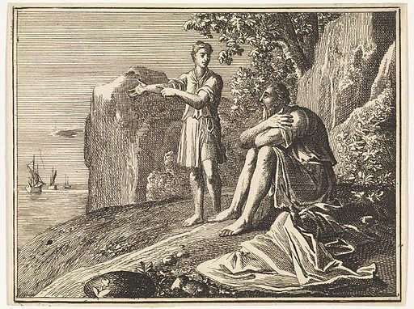
WEEK 4 / 16 August
Elijah’s Servant Sees a Small Cloud of Rain Caspar Luyken (1672-1708) 1712
Print. Rijksmuseum, Amsterdam

1 KINGS 18.41-46
⁴¹ And Elijah said to Ahab, ‘Go, eat and drink, for there is the sound of a heavy rain.’ ⁴² So Ahab went off to eat and drink, but Elijah climbed to the top of Carmel, bent down to the ground and put his face between his knees.
⁴³ ‘Go and look toward the sea,’ he told his servant. And he went up and looked.
‘There is nothing there,’ he said.
Seven times Elijah said, ‘Go back.’
⁴⁴ The seventh time the servant reported, ‘A cloud as small as a man’s hand is rising from the sea.’
So Elijah said, ‘Go and tell Ahab, “Hitch up your chariot and go down before the rain stops you.”’
⁴⁵ Meanwhile, the sky grew black with clouds, the wind rose, a heavy rainstorm came on and Ahab rode off to Jezreel. ⁴⁶ The power of the Lord came on Elijah and, tucking his cloak into his belt, he ran ahead of Ahab all the way to Jezreel.

MATTHEW 15.1-9
15 Then some Pharisees and teachers of the law came to Jesus from Jerusalem and asked, ² ‘Why do your disciples break the tradition of the elders? They don’t wash their hands before they eat!’
³ Jesus replied, ‘And why do you break the command of God for the sake of your tradition?⁴ For God said, “Honour your father and mother” and “Anyone who curses their father or mother is to be put to death.” ⁵ But you say that if anyone declares that what might have been used to help their father or mother is “devoted to God,” ⁶ they are not to “honour their father or mother” with it. Thus you nullify the word of God for the sake of your tradition. ⁷ You hypocrites! Isaiah was right when he prophesied about you:
⁸ ‘“These people honour me with their lips,
but their hearts are far from me.
⁹ They worship me in vain;
their teachings are merely human rules.”’

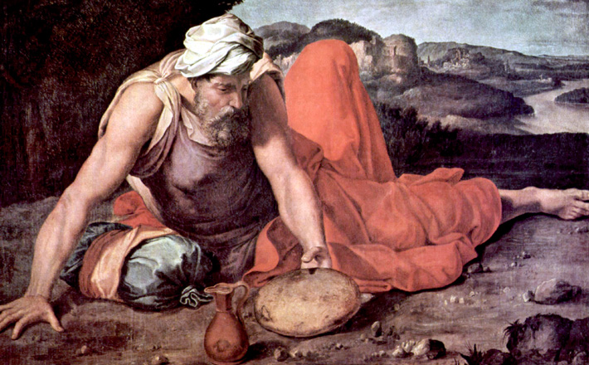
WEEK 5 / 23 August
Elijah in the Desert Daniele da Volterra (1509-1566) 1543-1547
Oil on canvas. Uffizi Galleries, Florence

1 KINGS 19.1-18
9 Now Ahab told Jezebel everything Elijah had done and how he had killed all the prophets with the sword. ² So Jezebel sent a messenger to Elijah to say, ‘May the gods deal with me, be it ever so severely, if by this time tomorrow I do not make your life like that of one of them.’
³ Elijah was afraid and ran for his life. When he came to Beersheba in Judah, he left his servant there, ⁴ while he himself went a day’s journey into the wilderness. He came to a broom bush, sat down under it and prayed that he might die. ‘I have had enough, Lord,’ he said. ‘Take my life; I am no better than my ancestors.’ ⁵ Then he lay down under the bush and fell asleep.
All at once an angel touched him and said, ‘Get up and eat.’ ⁶ He looked around, and there by his head was some bread baked over hot coals, and a jar of water. He ate and drank and then lay down again.
⁷ The angel of the Lord came back a second time and touched him and said, ‘Get up and eat, for the journey is too much for you.’ ⁸ So he got up and ate and drank. Strengthened by that food, he travelled for forty days and forty nights until he reached Horeb, the mountain of God. ⁹ There he went into a cave and spent the night. And the word of the Lord came to him: ‘What are you doing here, Elijah?’
¹⁰ He replied, ‘I have been very zealous for the Lord God Almighty. The Israelites have rejected your covenant, torn down your altars, and put your prophets to death with the sword. I am the only one left, and now they are trying to kill me too.’
¹¹ The Lord said, ‘Go out and stand on the mountain in the presence of the Lord, for the Lord is about to pass by.’
Then a great and powerful wind tore the mountains apart and shattered the rocks before the Lord, but the Lord was not in the wind. After the wind there was an earthquake, but the Lord was not in the earthquake. ¹² After the earthquake came a fire, but the Lord was not in the fire. And after the fire came a gentle whisper. ¹³ When Elijah heard it, he pulled his cloak over his face and went out and stood at the mouth of the cave.
Then a voice said to him, ‘What are you doing here, Elijah?’
¹⁴ He replied, ‘I have been very zealous for the Lord God Almighty. The Israelites have rejected your covenant, torn down your altars, and put your prophets to death with the sword. I am the only one left, and now they are trying to kill me too.’
¹⁵ The Lord said to him, ‘Go back the way you came, and go to the Desert of Damascus. When you get there, anoint Hazael king over Aram. ¹⁶ Also, anoint Jehu son of Nimshi king over Israel, and anoint Elisha son of Shaphat from Abel Meholah to succeed you as prophet. ¹⁷ Jehu will put to death any who escape the sword of Hazael, and Elisha will put to death any who escape the sword of Jehu. ¹⁸ Yet I reserve seven thousand in Israel – all whose knees have not bowed down to Baal and whose mouths have not kissed him.’

MATTHEW 16.1-4
16 The Pharisees and Sadducees came to Jesus and tested him by asking him to show them a sign from heaven.
² He replied, ‘When evening comes, you say, “It will be fair weather, for the sky is red,” ³ and in the morning, “Today it will be stormy, for the sky is red and overcast.” You know how to interpret the appearance of the sky, but you cannot interpret the signs of the times. ⁴ A wicked and adulterous generation looks for a sign, but none will be given it except the sign of Jonah.’ Jesus then left them and went away.

