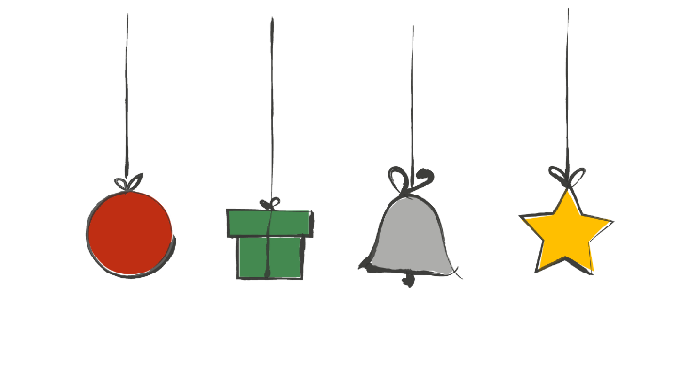

Share Joy

Share joy this Advent by doing something good every day for 24
days – and raise money for The Children’s Society.

You can do them in any order, just remember to tick them off as you complete each good deed!

Ask friends and family to sponsor
you or make a donation.

Overleaf there’s a special prayer to say together on Christmas Day.

Dress up as your favourite character from the Christmas story
Pray for children caring for their families over Christmas
Write a Christmas card for your postal worker
Talk to someone on Christmas Day who might be sad or lonely
Think of 3 things to thank God for
Send a card to your MP, asking them to promote the needs of children in their work
Imagine you’re someone in the Christmas story. What are they thinking?
Tell someone your favourite Christmas cracker joke
Put out some food for birds
Donate a toy to charity
Find out the difference between a refugee and a migrant
Share a happy memory or inspiring thought with someone
Do something you wouldn’t normally do, but Jesus would
Pray for children who are alone this Christmas
Surprise your mum or carer by tidying your room
Compliment three people today
Bake a Christingle cake or make your own Christingle
Write to someone telling them why you love them
Say something positive to everyone you speak to today
Make a no-churn Christmas ice-cream! For recipe ideas go to https://bit.ly/tcs-advent-ice
Pray for someone you think is having a difficult time
Give a small bunch of flowers to someone
Donate some food to a food bank
Write a Christmas card to your bin collector

Prayer for Christmas

Lord Jesus, born in a stable,
Give courage to all who do not have a safe place to call home.

Lord Jesus, for whom the angels sang,
Give the song of the kingdom to all who weep.

Lord Jesus, worshipped by the shepherds,
Give peace on earth to all who are oppressed.

Lord Jesus, visited by both wise and meek,
Give wisdom and humility to all who govern.

Lord Jesus, whose radiance filled a lowly manger,
shine in our lives today,
give hope to all vulnerable children and young people
and bless the work of The Children’s Society in giving them a brighter future.

Amen

Some sections of this prayer adapted from New Patterns for Worship.

