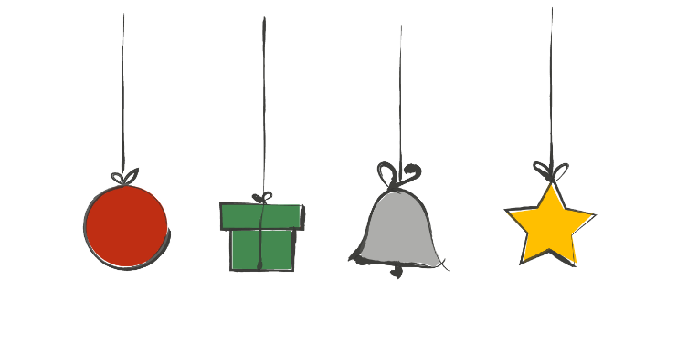

Share Joy

Share joy this Advent by doing something good every day for 24
days – and raise money for The Children’s Society.

You can do them in any order, just remember to tick them off as you complete each good deed!

Ask friends and family to sponsor
you or make a donation.

Overleaf there’s a special prayer to say together on Christmas Day.

Notice when you have been hard on yourself or others and be kind instead
Pray for children caring for their families over Christmas
Write a Christmas card for your postal worker
Talk to someone on Christmas Day who might be sad or lonely
Think of 3 things to thank God for
Send a card to your MP, asking them to promote the needs of children in their work
Imagine you’re someone in the Christmas story. What are they thinking?
Tell someone your favourite Christmas cracker joke
Put out some food for birds
Buy a gift for a child via The Children’s Society’s Give Joy website
givejoy.org.uk
Find out the difference between a refugee and a migrant
Share a happy memory or inspiring thought with someone
Do something you wouldn’t normally do, but Jesus would
Pray for children who are alone this Christmas
Tidy a shared space
Compliment three people today
Bake a Christingle cake or make your own Christingle
Write to someone telling them why you love them
Say something positive to everyone you speak to today
Make a no-churn Christmas ice-cream! For recipe ideas go to https://bit.ly/tcs-advent-ice
Pray for someone you think is having a difficult time
Give a small bunch of flowers to someone
Donate some food to a food bank
Write a Christmas card to your bin collector

Prayer for Christmas

Loving God,

As we hear again the songs of Christmas
resounding the glory of your praise,
we remember those who do not yet know the wonders
of your love.

We pray for children everywhere,
that they may know security and peace
and for those who live in unsafe places or lack the basic
necessities of life.

We pray too for those whose lives are fraught with worry.

We thank you for all professionals who work with children
and for the partnerships that exist with The Children’s Society
at this time.

We ask for a strengthening between different agencies,
so that more and more children would find the support and help they need.

Through Jesus Christ our Lord.

Amen.

Sophie Lelley, Bishop of Doncaster

